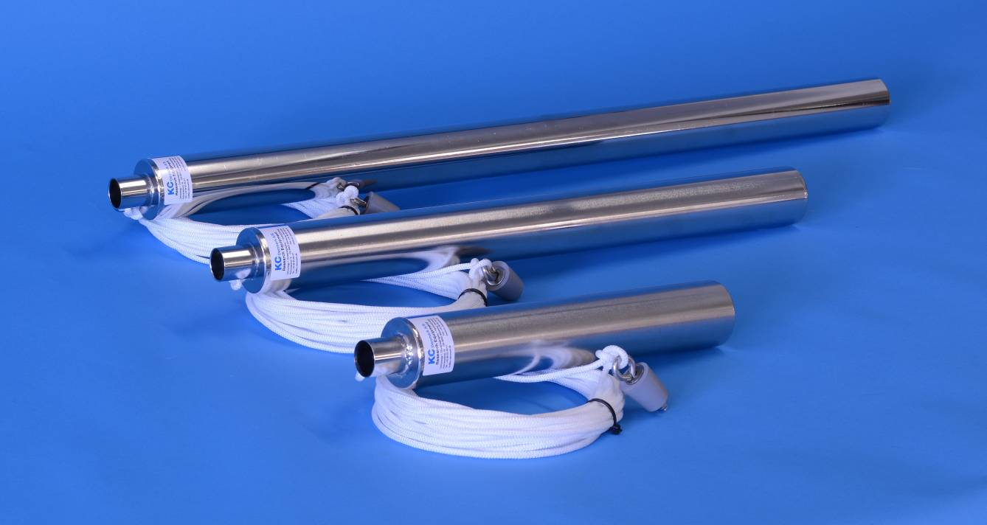
Small Water Sampler
Stainless steel
0,5 – 1,0 – 1,5 L
Model 11.2xx

KC Denmark A/S
Research Equipment
Limnology  Oceanography  Hydrobiology
Quotation
Small stainless steel water sampler |  | Ordering no.  11.210
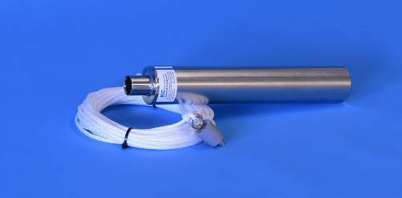  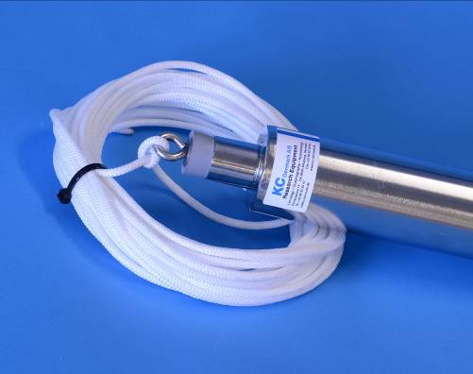 | The water sampler is made of AISI 316 stainless steel with an outer diameter of 54 mm.  Finish: Electro polish.  The top of the sampler has a rubber bung, which closes the sampler until it reaches the desired depth.  The inner of the sample tube has a stainless steel weight, 650 g for improving the deployment.  Standard delivery comes with 10 meters of Ø5 mm unmarked rope.  Volume: 0,5 – 1,0 or 1,5 L.  Recommended depth: Max. 20 m; for larger depths the bung may get stuck inside the sampler.

Order no. | Qty. | Product |  |  | Prices - Euro
11.210 | 1 | Small water sampler, complete  - Volume 0,5 L  - AISI 316 stainless steel  - Finish: Electro polish  - Outer diameter: 54 mm  - Length: 340 mm  - Line: Standard mounting comes with 10 m of Ø5 mm rope (unmarked). Other length upon request  - Recommended depth: Max. 20 m  - Weight: 1,6 kg | 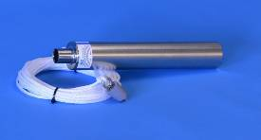 |  | 198,00

11.211 | 1 | Small water sampler, complete  - Volume 1,0 L  - AISI 316 stainless steel  - Finish: Electro polish  - Outer diameter: 54 mm  - Length: 600 mm  - Line: Standard mounting comes with 10 m of Ø5 mm rope (unmarked)  - Recommended depth: Max. 20 m  - Weight: 2,2 kg | 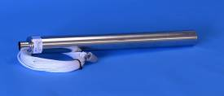 | 239,00
11.212 | 1 | Small water sampler, complete  - Volume 1,5 L  - AISI 316 stainless steel  - Finish: Electro polish  - Outer diameter: 54 mm  - Length: 860 mm  - Line: Standard mounting comes with 10 m of Ø5 mm rope (unmarked).  - Recommended depth: Max. 20 m  - Weight: 2,8 kg | 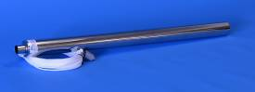 | 279,00
Winches
Order no. | Qty. | Product |  | Prices - Euro
17.200 | 1 | Stuff winch  - Capacity: 40-50 m of Ø5 mm line.  - Diameter: Ø30 cm  - Made of strong Beaver Nylon,  - 2 pcs of AISI 316 stainless steel rings  - Without line  - Weight: 0,3 kg | 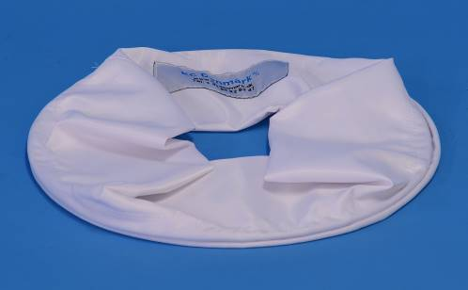 | 55,00
Polyester lines, 5 mm
17.300 | 1 | 5 mm polyester line, unmarked, each m |  | 2,00
17.399 | 1 | 5 mm polyester line, marked every meter, length 10 m | 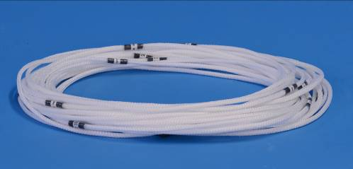 | 79,00
17.400 | 1 | 5 mm polyester line, marked every meter, length 15 m |  | 92,00
17.401 | 1 | 5 mm polyester line, marked every meter, length 20 m |  | 107,00

Shipment instructions
The following instructions are only intended as a quick guide for you if you wish to estimate the shipping costs.

Price does not include package, freight, insurance and delivery costs. Upon ordering, we will be pleased to quote CIP delivery to your place.
Pallet, L x W x H,
All prices are ex. VAT and valid upon December 31, 2017 | Rev.: January 1, 2017 - lkj
Subject to change in prices, specifications, dimensions and weights for all products. Any change can be made without previous warning.
Subject to any mistake, mistyping, misprints or any error occurred in all written material, caused by any software/hardware, virus, transmitting files via internet/copying of files or errors on any type of media.

KC Denmark A/S
Research Equipment
Limnology  Oceanography  Hydrobiology

E-mail: kc@kc-denmark.dk website: TTTThttp://www.kc-denmark.dk/
Holmbladsvej 17-19, DK 8600 Silkeborg, Denmark. Tel. +45 86 82 83 47. Fax +45 86 82 49 50
Bank: Sydbank. SWIFT: SYBKDK22 IBAN DK5070460000104832
VAT no. DK 29 61 96 62

