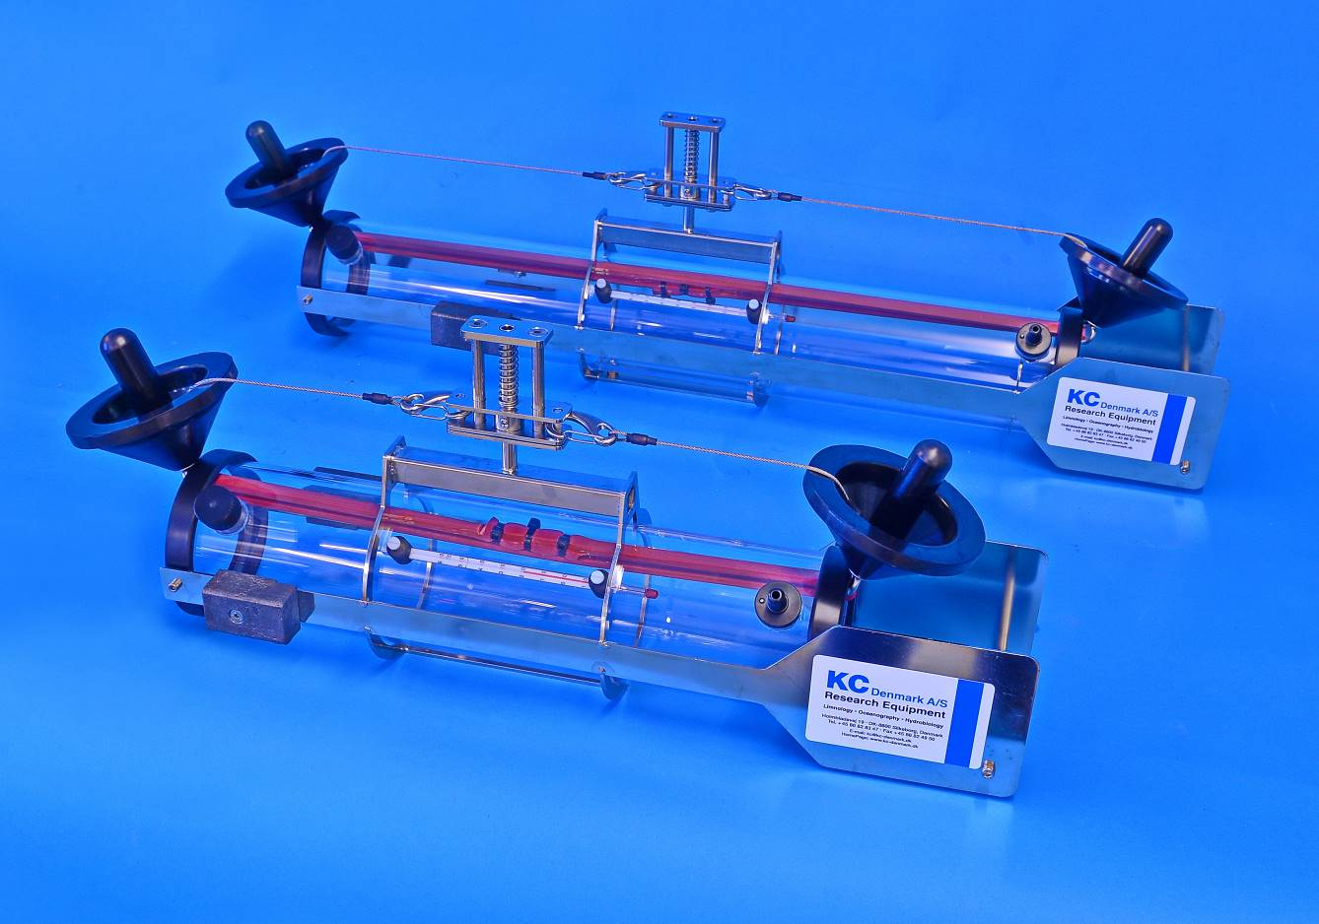
The sampler comes with drop messenger, not shown on the photo
Van Dorn Water Sampler

Model 11.xxx series

KC Denmark A/S
Research Equipment
Limnology  Oceanography  Hydrobiology
Quotation
Van Dorn Horizontal Water Sampler |  |  |  |  |  | Ordering no.  11.100 (2.0 L)  11.200 (3.0 L)  11.300 (5.0 L)
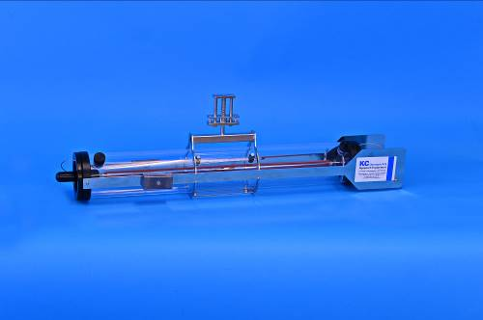  Van Dorn water sampler with integrated direction fin.  The water sampler comes in 3 sizes, 2,0 - 3,0 and 5,0 L. |  |  |  | The water sampler is based on the Van Dorn design, and is has the same characteristic as the Beta™ Van Dorn samplers, suitable for sampling trace metals, organics and other chemical sampling.  The end seals are EPDM rubber and the tubing is Para rubber.  The horizontal water sampler is intended for taking organic water samples near the bottom in lakes, streams, or in stratified water bodies.  It is made of sturdy transparent acrylic and has a double releaser, activated by a drop messenger. The releaser is made of AISI 316 stainless steel. Standard delivery has small stainless steel parts inside. Can also be delivered with a non-metallic interior. Please add part no. 11.320.  The water sampler has a standard thermometer, non-mercury. Temperature range between –10 to +60 °C.  Standard drop messenger made of brass. 2 other models available; one of these (60.001) has open/close functionality.  All samplers are equipped with integrated direction fins for stabilization in flowing water.  Recommended depth: Max. 70 m, dismount the thermometer and the water sampler can be used at any depth.
Order no. | Qty. |  | Product |  |  | Prices - Euro
11.100 | 1 |  | Water sampler, complete  - Capacity 2,0 L  - Transparent acrylic  - Drop messenger, (brass), is included  - Internal thermometer, non-mercury, range  -10 °C to +60 °C  - Integrated direction fin for stabilization in flowing water  - AISI 316 stainless steel  - Length 450 mm  - Height: 265 mm  - Width: 175 mm  - Recommended line:  Ø5 mm polyester  - Weight: 4,8 kg |  | 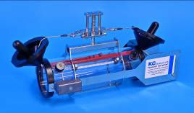 | 941,00
11.200 |  | 1 | Water sampler, complete  - Capacity 3,0 L  - Transparent acrylic  - Drop messenger, (brass), is included  - Internal thermometer, non-mercury, range  -10 °C to +60 °C  - Integrated direction fin for stabilization in flowing water  - AISI 316 stainless steel  - Length 580 mm  - Height: 265 mm  - Width: 175 mm  - Recommended line:  Ø5 mm polyester  - Weight: 5,3 kg |  | 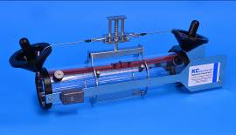 | 1.048,00

11.300 | 1 | Water sampler, complete  - Capacity 5,0 L  - Transparent acrylic  - Drop messenger, (brass), is included  - Internal thermometer, non-mercury, range  -10 °C to +60 °C  - Integrated direction fin for stabilization in flowing water  - AISI 316 stainless steel  - Length 830 mm  - Height: 265 mm  - Width: 175 mm  - Recommended line:  Ø5 mm  - Weight: 6,1 kg | 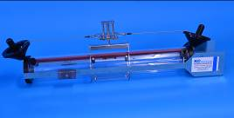 | 1.163,00
11.320 | 1 | Non-metallic interior  - All Van Dorn samplers can be delivered with a non-metallic interior  - Additional price each sampler |  | 127,00

Spare parts/other parts recommended
Order no. | Qty. | Product |  | Prices – Euro
10.001 | 1 | Drop messenger  - Brass (standard delivery)  - Weight 500 g |  | 83,00
10.002 | 1 | Drop messenger  - AISI 316 stainless steel  - Weight 500 g |  | 107,00
60.001 | 1 | Drop messenger, 400 gr.  - Construction: Open/close  - Stainless steel  - Max. Ø6 mm wire  - To be attached to the line at any point. Turn one part of the messenger, insert the line and close the messenger  - For all Van Dorn water bottles | 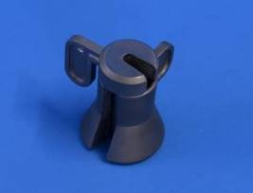 | 128,00
11.007 | 1 | Thermometer  - Non-mercury  - Range: -10 °C +60 °C  - Length: 205 mm |  | 63,00
11.325 | 1 | Lids for Van Dorn water sampler  - 2 lids manufactured from EPDM rubber  - Comes with handle inclusive the hooks and the Para rubber band  - Upon ordering pls. inform for size of sampler  - Weight: 0,6 kg | 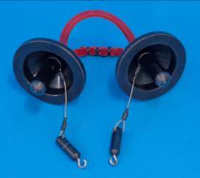 | 171,00
68.002-V | 1 | - Plastic air valve  - With seal and O-ring | 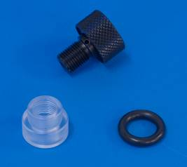 | 85,00
68.003-V | 1 | - Plastic valve for water outlet  - With O-rings and stop ring | 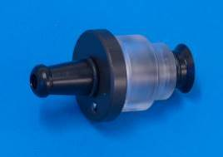 | 96,00

68.004-V | 1 | - Para/Latex rubber band (sea water resistant) and 2 strips.  - By ordering please inform for the size of water sampler. | 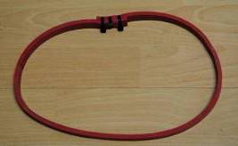 | 22,00
Nefab-01 | 1 | Transport box  - Only for 11.100 or 11.200 water sampler  - Room for deployment line  - IPPC certified  - Inner dimensions:  L x W x H:  670 x 250 x 250 mm  - Outer dimensions:  L x W x H:  690 x 280 x 300 mm  - Weight: 4,5 kg | 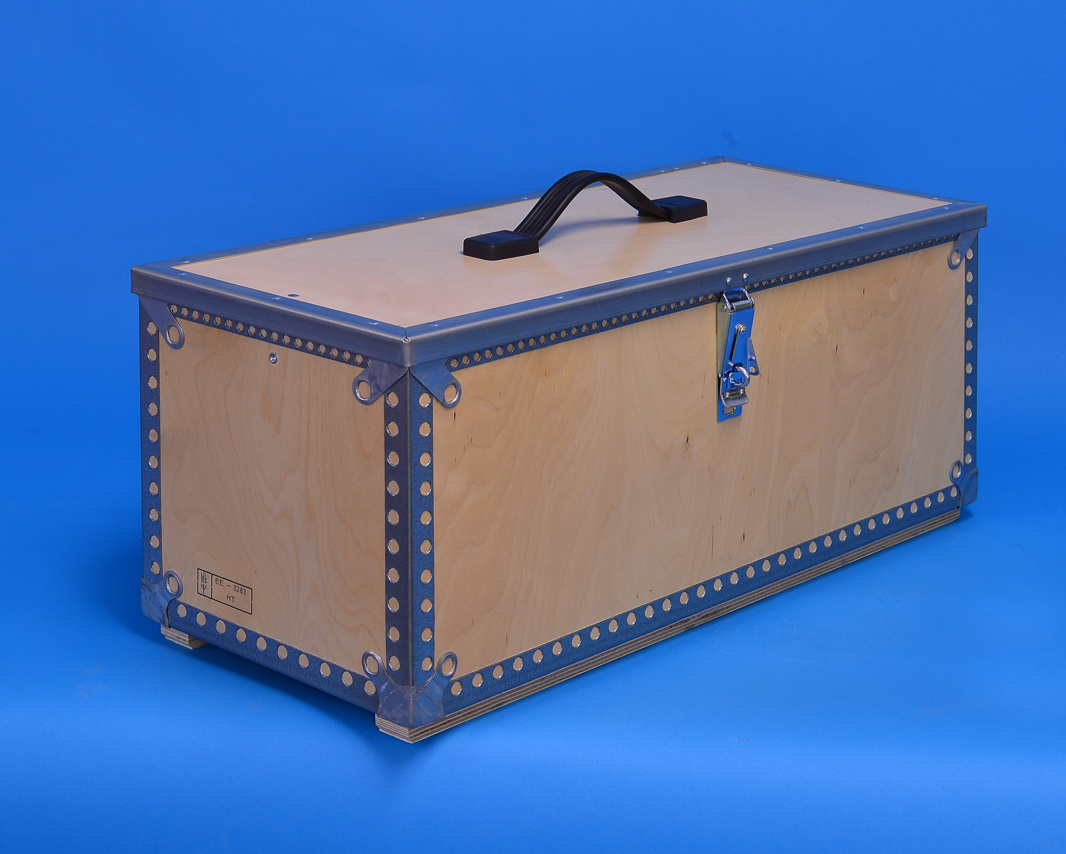 | 139,00
Nefab-02 | 1 | Transport box  - Only for 11.100 or 11.200 water sampler  - Room for deployment line and more accessories  - IPPC certified  - Inner dimensions:  L x W x H:  740 x 245 x 300 mm  - Outer dimensions:  L x W x H:  810 x 290 x 330 mm  - Weight: 7,6 kg | 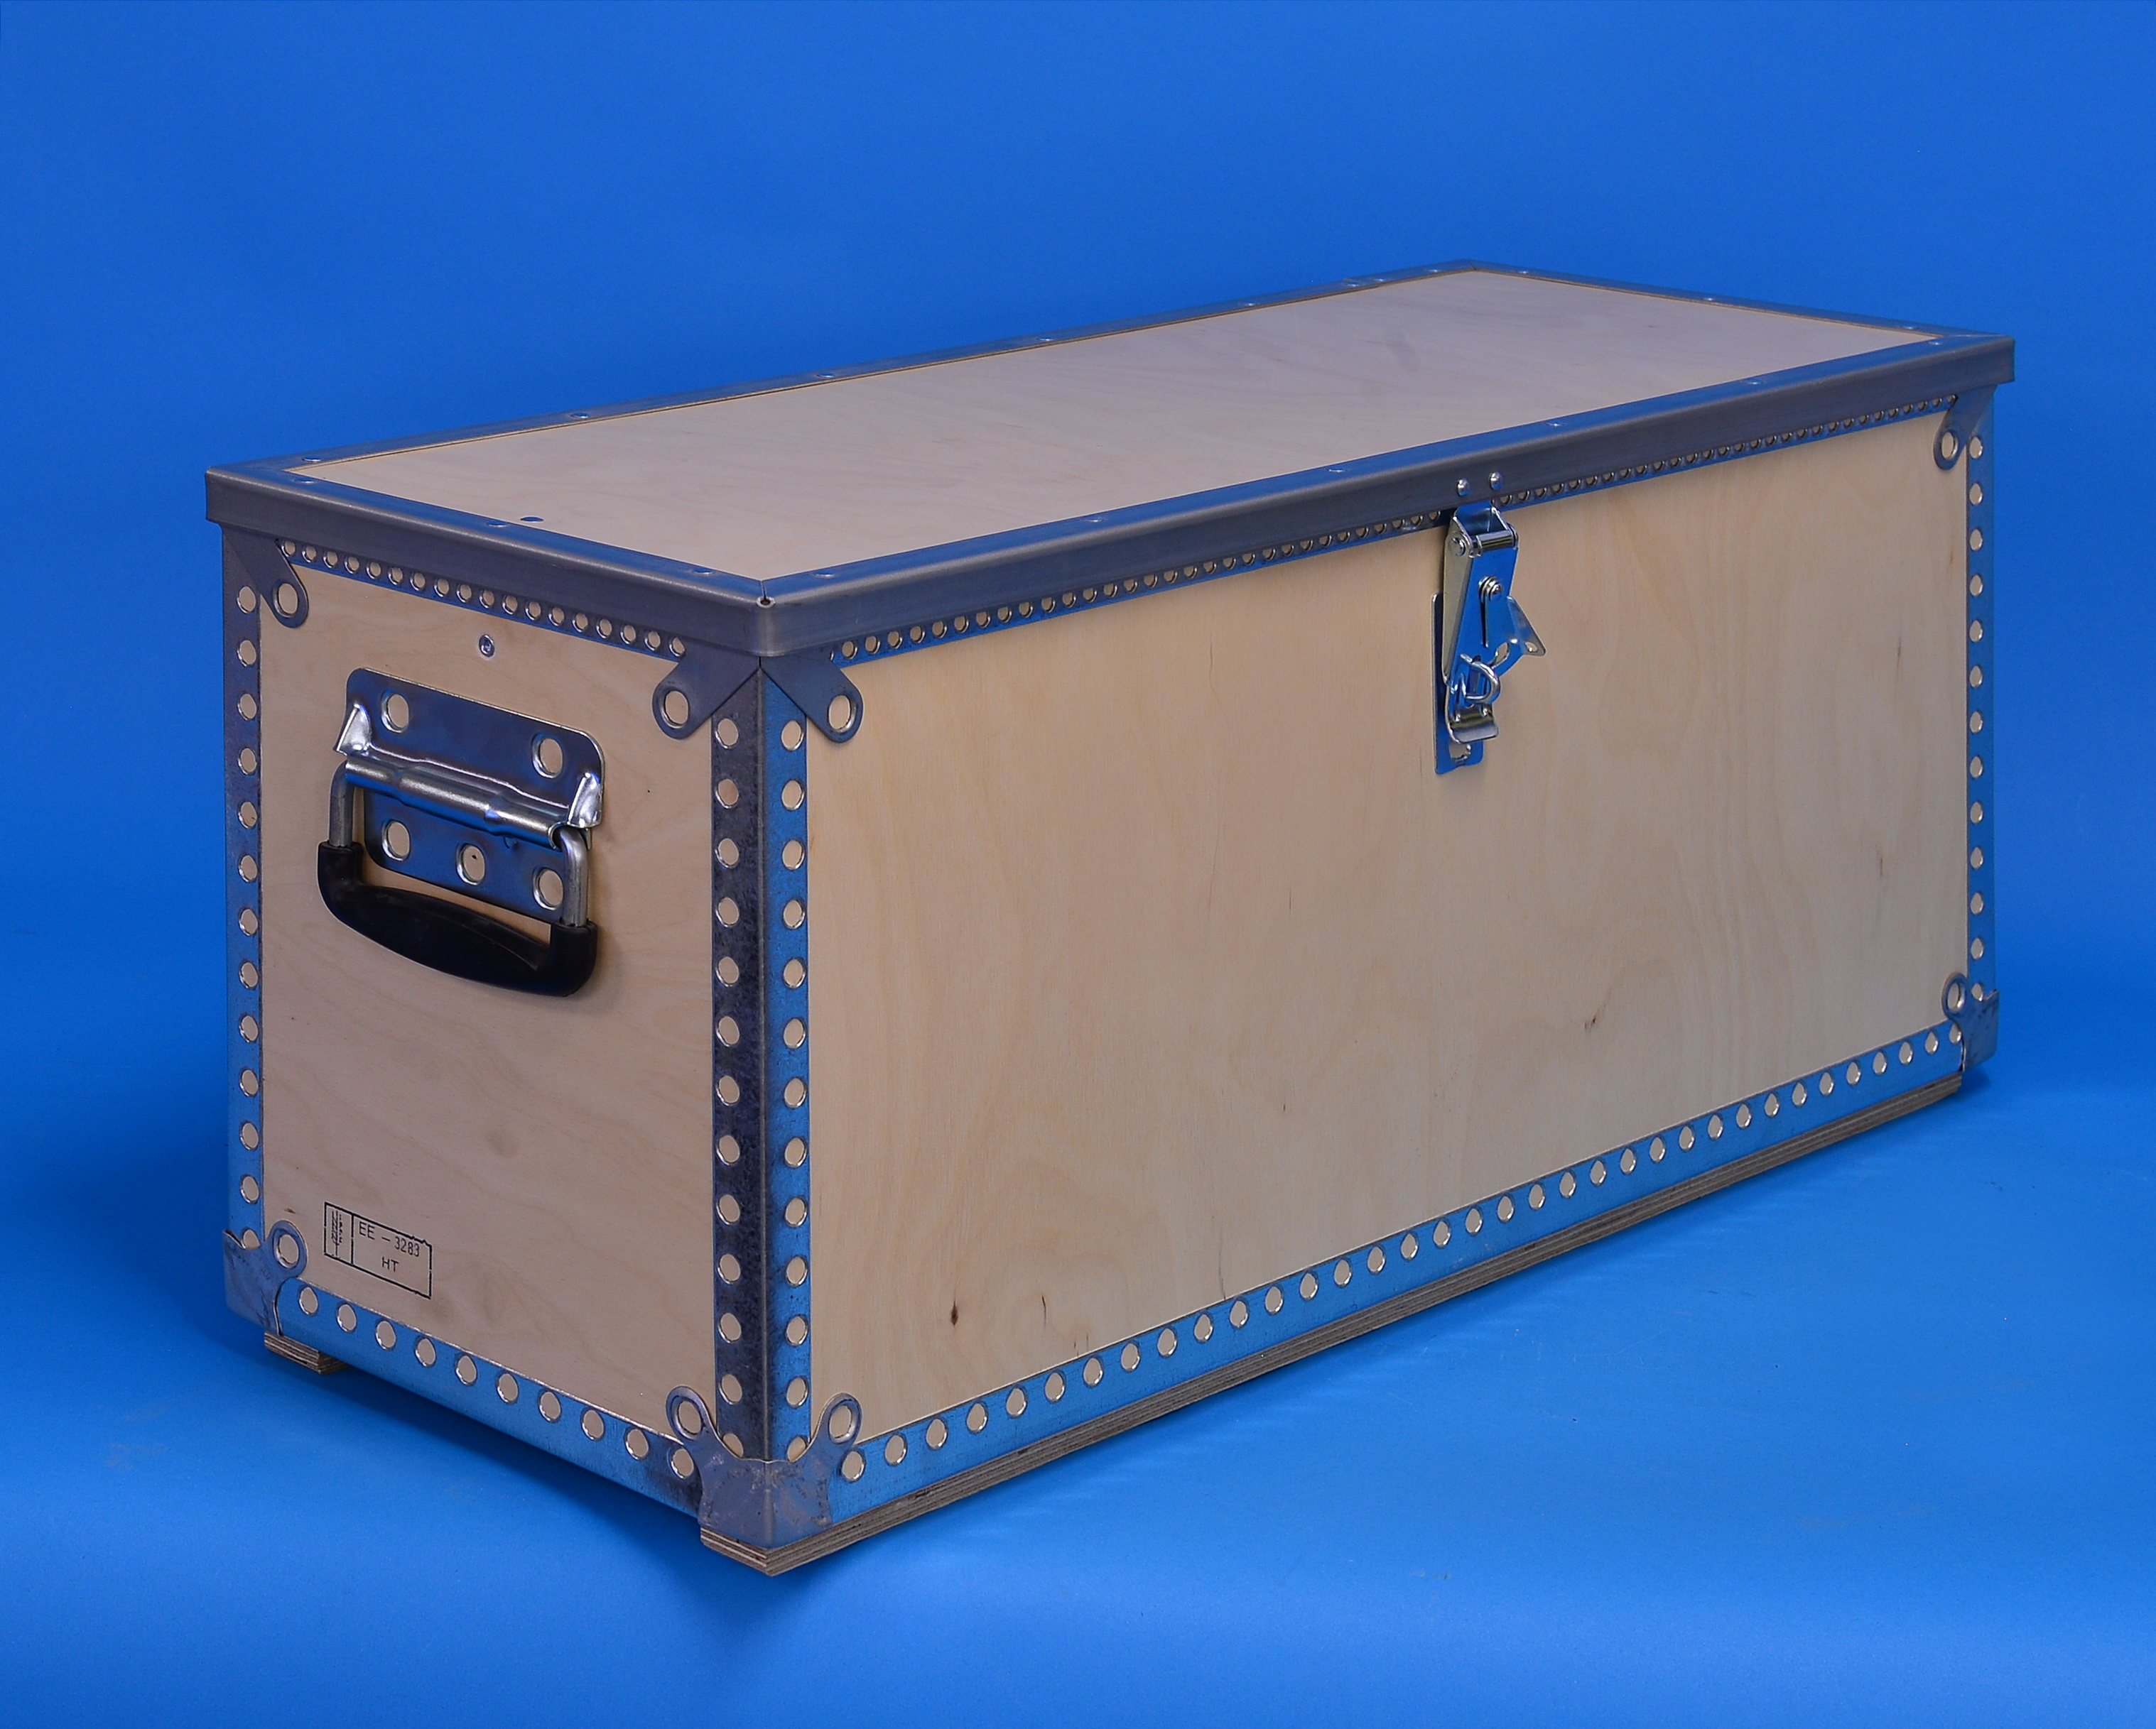 | 189,00
17.201 | 1 | Stuff winch, without line  - Diameter: 40 cm  - Made of strong Beaver Nylon  - 2 stainless AISI 316 rings inserted  - Capacity: 100 m of Ø5 mm polyester line | 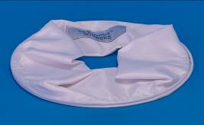 | 63,00
Polyester lines, diameter 5 mm
17.300 | 1 | Polyester line  - Diameter 5 mm  - Unmarked, each meter  - Tensile strength 180 kp |  | 2,00
 |  | Polyester line  - Diameter 5 mm  - Marked every meter  - Strong markings, viewable from more sides  - Tensile strength 180 kp  - For available lengths, see below | 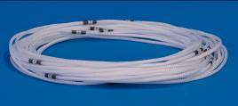
17.399 | 1 | Length 10 m |  | 79,00
17.400 | 1 | Length 15 m |  | 91,00
17.401 | 1 | Length 20 m |  | 107,00
17.402 | 1 | Length 25 m |  | 122,00
17.403 | 1 | Length 30 m |  | 135,00
17.405 | 1 | Length 40 m |  | 215,00
17.407 | 1 | Length 50 m |  | 245,00
17.409 | 1 | Length 60 m |  | 272,00
17.410 | 1 | Length 70 m |  | 309,00
Technical information
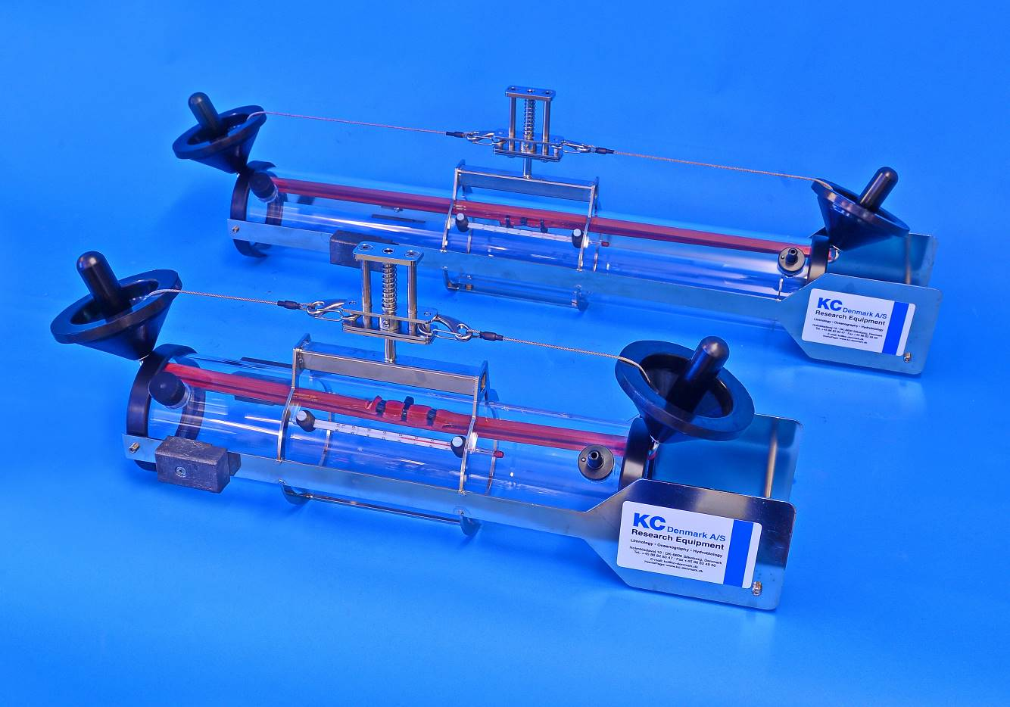The water sampler is based on the Van Dorn design.

The horizontal water sampler is intended for taking water samples near the bottom in lakes, streams, or in stratified water bodies.

All samplers are equipped with direction fins for stabilization in flowing water. The fins are equipped with balance weights.

It is manufactured of sturdy transparent acrylic and has a double releaser, activated by a drop messenger. The releaser is made of AISI 316 stainless steel.

The water sampler has a standard, non-Mercury thermometer mounted. Temperature range between –10 and +60 °C scaled each degree. Space between scaling: 2 mm. Drop messenger is included.

The water sampler comes in 3 sizes, 2,0 - 3,0 and 5,0 L.

Shipment instructions
The following instructions are only intended as a quick guide for you if you wish to estimate the shipping costs.
Price does not include package, freight, insurance and delivery costs. Upon ordering, we will be pleased to quote CIP delivery to your place.
L x W x H: 11.100/11.200/11.300 | 103 x 23 x 23 cm
All prices are ex. VAT and valid until December 31, 2017 | Rev.: February 14, 2017 - lkj
Subject to change in prices, specifications, dimensions and weights for all products. Any change can be made without previous warning.
Subject to any mistake, mistyping, misprints or any error occurred in all written material, caused by any software/hardware, virus, transmitting files via internet/copying of files or errors on any type of media.

KC Denmark A/S
Research Equipment
Limnology  Oceanography  Hydrobiology

E-mail: kc@kc-denmark.dk website: http://www.kc-denmark.dk/
Holmbladsvej 17-19, DK 8600 Silkeborg, Denmark. Tel. +45 86 82 83 47.
Bank: Sydbank. SWIFT: SYBKDK22 IBAN DK5070460000104832
VAT no. DK 29 61 96 62

